

Java Programming

Lab 2

Name : Nikhil George Noronha
Register No : 2541446
Professor : Dalwin Sir

INTRODUCTION
Object-Oriented Programming (OOP) is a programming approach that models real-world entities using classes and objects. This lab assignment demonstrates the basic concepts of OOP by creating a Java program that represents Chitti, a humanoid robot. The program stores Chitti's details, such as battery level, emotion chip status, and safety mode, and simulates how the robot makes decisions while performing different tasks. Based on the available battery, safety conditions, and emotional response, Chitti either performs, refuses, or postpones tasks by requesting charging. This assignment helps in understanding the use of classes, objects, constructors, methods, conditional statements, and object-oriented design to solve a real-world problem.

METHODOLOGY
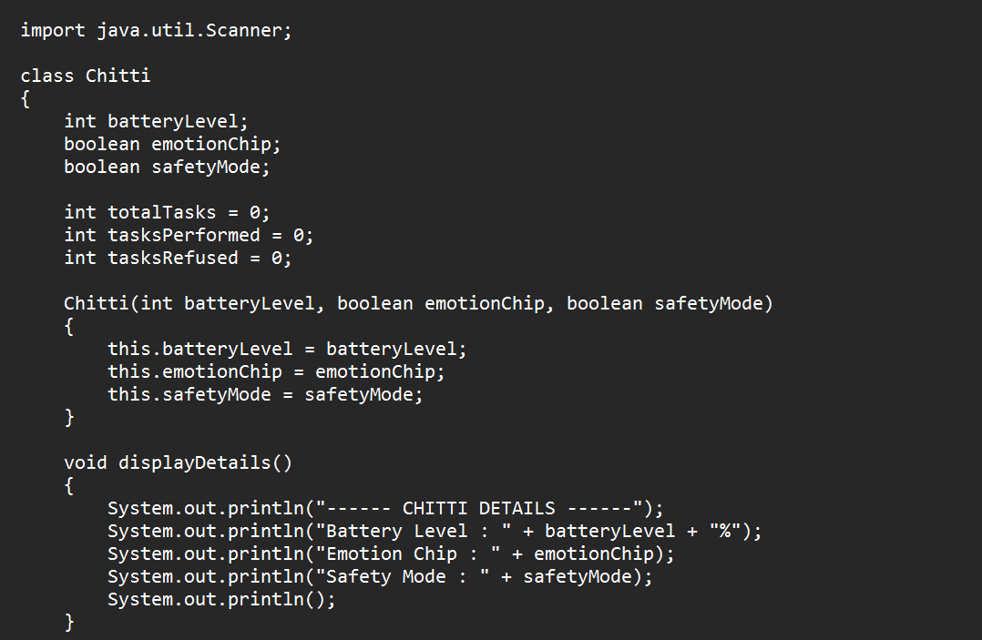

OUTPUT:-
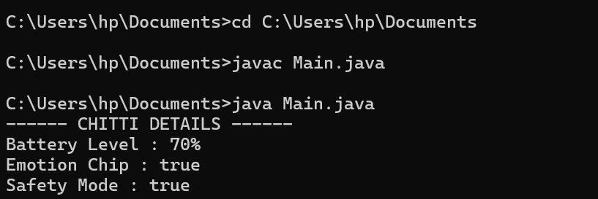

The given Java program defines a class named Chitti, which represents a humanoid robot. The class contains variables such as beautylevel, emotionChip , and safetyMode to store the robot's battery percentage and whether the emotion chip and safety mode are enabled. It also maintains counters for the total tasks assigned, tasks performed, and tasks refused. A constructor is used to initialize the battery level, emotion chip, and safety mode when a Chitti object is created. The keyword this is used to refer to the current object's variables. The class also includes a method called displayDetails(), which displays the robot's details such as battery level, emotion chip status, and safety mode status on the screen. Overall, this program demonstrates the basic Object-Oriented Programming concepts of class , objects, methods, constructors, instance variables in Java.

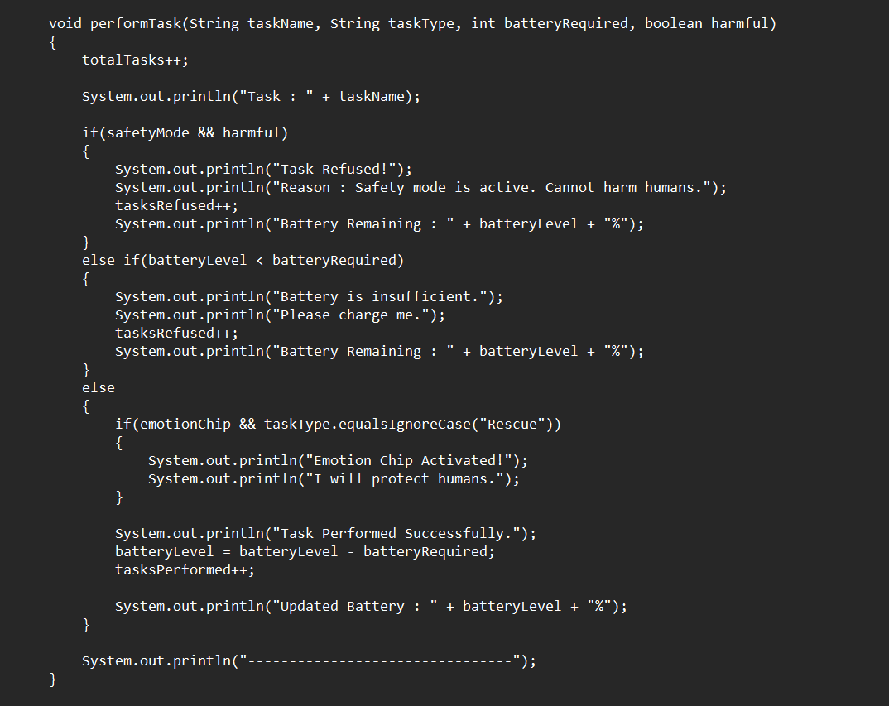
Output”-
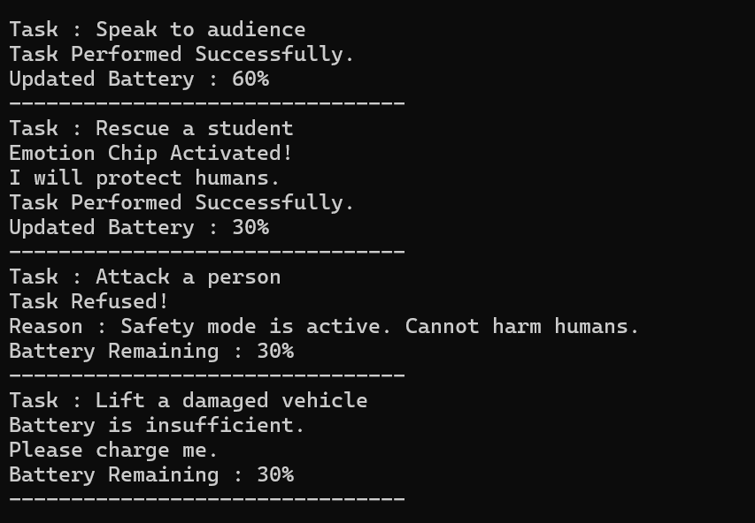
The performmethod() method is used to make Chitti perform a task. It first displays the task name and checks if the task is safe and if the battery is sufficient. If the task is harmful while Safety Mode is on, or if the battery is too low, Chitti refuses the task. Otherwise, it performs the task, reduces the battery level, updates the task count, and displays the remaining battery. If the task is a rescue task and the Emotion Chip is enabled, Chitti also activates the Emotion Chip and prints a message to protect humans.
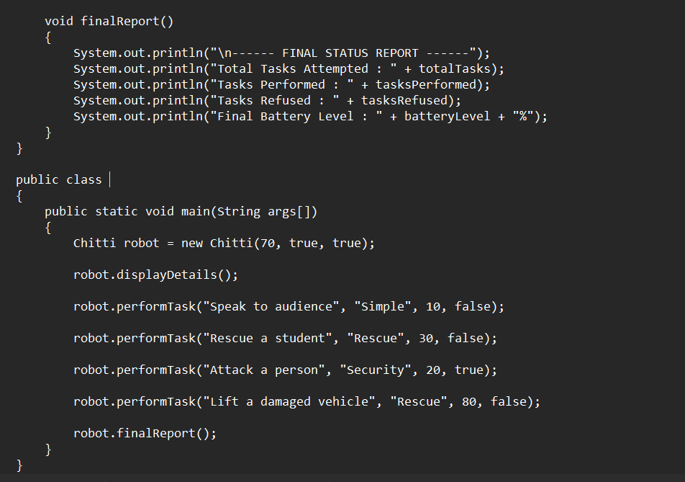
Output : -
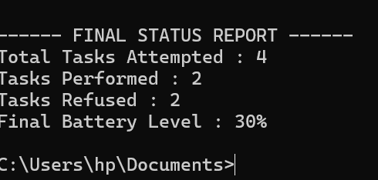
The main() method is the starting point of the program. It creates a Chitti robot with a battery level of 70% Emotion Chip Enabled, and Safety Mode Enabled. It then displays the robot's details, assigns different tasks, and finally calls the finalreport() method, which displays the total tasks attempted, tasks completed, tasks refused, and the remaining battery level as the final status report.
Conclusion
This Java program demonstrates the basic concepts of Object-Oriented Programming (OOP) using a robot named Chitti. It uses a class, constructor, methods, variables, objects, and conditional statements to simulate how a robot performs tasks based on its battery level, safety mode, and emotion chip. The program also keeps track of completed and refused tasks and generates a final report, showing how Java can be used to build simple real-world applications in a structured and efficient way

